1. Executive Summary
The problem in one line
Riders abandon their booking the moment they see “No drivers available” — even though a driver often becomes available nearby within minutes.
Ride-hailing platforms treat driver supply as binary: a driver is either available right now, or the platform shows nothing at all. In reality, supply is continuous — drivers finish trips, come back online, and re-enter a rider's radius every few minutes. Ride-hailing platforms already operate on very sophisticated ETAs and dispatch prediction systems. Public engineering documentation from Uber (DeepETA) demonstrates this capability, although rider-facing availability forecasts are not publicly documented.
This case study proposes Predictive Driver Availability — a feature that forecasts near-term supply and tells the rider “a driver is expected in ~3 minutes” instead of a flat rejection. The goal is to convert bookings that would otherwise be abandoned into completed rides, without adding a single new driver to the marketplace.This proposal is based on publicly available product documentation and engineering material, together with observed rider pain points.

Why It Matters
- Lost bookings from “no drivers available” are a direct, measurable hit to conversion and GMV — and they are entirely a UX/information problem, not a supply problem, in a meaningful share of cases.
- User research (Play Store reviews, support forums, social complaints) shows this is a recurring, emotionally charged pain point — riders describe missing flights, being late to hospitals, and switching to competitor apps.
- Uber's public "Wait & Save" feature suggests that riders are willing to accept longer waits when the trade-off is transparent. This validates rider willingness to wait for value, although the feature addresses price rather than availability.

Proposed Solution
A three-part response calibrated to how confident the prediction is:
- Smart Wait — when the model is confident a driver will be available soon, tell the rider “driver expected in ~3 min” and let them choose to wait.
- Expanded Search — when local supply is thin, silently widen the search radius before declaring “no drivers.”
- Notify Me — when no near-term prediction is confident, let the rider leave the app and get pinged the moment a driver becomes available, recovering demand that would otherwise be lost entirely.

Expected Business Impact
Section 18 presents an illustrative scenario showing how modest recovery rates could translate into meaningful incremental ride completions. These figures are intended to demonstrate potential impact rather than predict business outcomes.

2. Problem Statement
Observed user pain: Riders abandon searches when they see “No drivers available,” especially during peak hours, time-critical trips or in lower-density areas. The immediate frustration is on both the delay and the uncertainty of getting a driver.
A weak version of this problem statement says “users don't like waiting.” The real problem has three layers, each pointing to a different owner and fix.

2.1 User, Business, and Marketplace Problem
User: when a rider sees “No drivers available,” they have no information about whether that condition will last 30 seconds or 30 minutes. Facing that uncertainty, most riders don't wait to find out — they close the app, and repeat exposure builds a quiet impression that the platform is unreliable at exactly the moments (peak hours, airport runs, late night) when reliability matters most.
Business: a binary availability signal has three downstream costs — abandoned bookings that were real demand; lower conversion concentrated in the highest-value moments (surge, peak, low-supply zones); and customer switching, since in multi-app markets (India, LatAm, SEA) the switching cost is close to zero.
Marketplace: drivers become available continuously — a driver finishing a drop-off two minutes away is, for practical purposes, “almost available.” The matching and ETA systems already model this in the background (this is precisely what Uber's DeepETA and similar systems are built for [1]). The product surface only exposes a snapshot of current supply, not the forecast the backend can already produce.
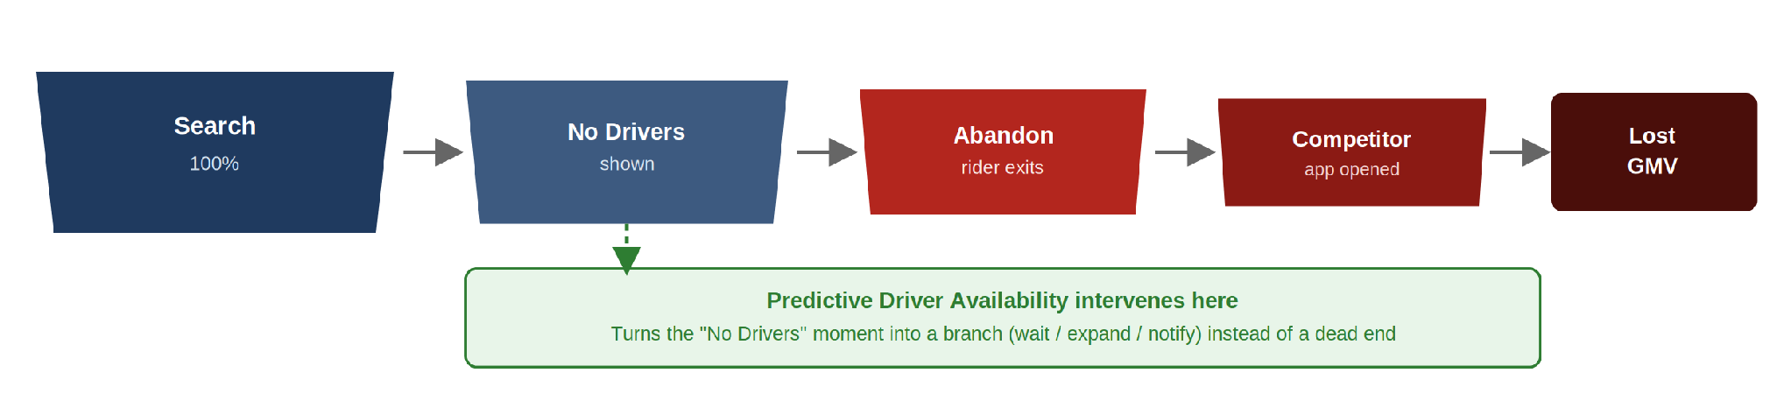
Figure 1. Where demand is lost today, and where Predictive Driver Availability intervenes.

3. Why This Matters — Evidence the Problem Is Real
Patterns pulled from Play Store reviews, Uber/Lyft support forums, and consumer complaint boards converge on a small number of recurring complaints:
Theme | Representative pattern | What it signals
Long, uncertain waits | Riders report a short quoted wait, the app failing to find a driver, then an upsell to a pricier tier for the same or worse wait. | Riders perceive the system as opaque, not just slow.
Missed time-critical trips | Complaints describe missed flights and appointments after a “no drivers” message, sometimes with a cancellation fee charged on top. | A bad availability signal causes active harm to trust, not just a lost booking.
Competitor switching | Riders compare fares and wait times across Uber and other apps in the same complaint, sometimes same night. | Switching cost is near zero; a rejection is a live opportunity for a competitor.
Confusion about wait trade-offs | Uber's “Wait & Save” (lower fare for a longer wait) draws steady skeptical commentary about how the wait time is determined. | Riders will accept a wait — only when they trust the number attached to it.
Source: Google Play Store reviews (Uber Rider app), Uber Support community threads, ConsumerAffairs.com and BBB.org complaint archives, and social commentary on “Wait & Save” (2024–2026). [1]

Sizing the Problem
- Frequency: this pattern recurs across every review surface checked, across multiple years — a steady-state experience, not a one-off outage, concentrated at peak hours and in lower-density zones.
- Cost per incident: missed flights, hospital visits, and cancellation fees recur in complaints — these are the trips riders care most about completing.
- Revealed willingness to wait: “Wait & Save” is now live in 10+ Indian cities [2], proving riders accept a wait when given clear terms — the barrier is information, not patience.

4. Market Research — How Competitors Handle This Today
Every major ride-hailing platform manages supply-demand imbalance using ETA prediction, dispatch systems, pricing, and rider experience design. This section reviews publicly observable product behavior to understand how platforms communicate availability to riders. [3]
[The comparisons below are based on publicly available rider-facing product documentation and observed product flows as of mid-2026. They do not rule out region-specific experiments or internal features that are not publicly documented.]
Platform | On “no drivers” | Predicts future availability? | Expands search radius? | Notify-later option?
Uber | Shows “No drivers available” or a long ETA; separately offers “Wait & Save” for a lower fare at a longer, algorithm-set wait. | Partially, but not exposed as a general availability forecast on rejected searches. | Limited — primarily via surge/price adjustment | No general-purpose “notify me” for a rejected search.
Lyft | Similar binary unavailability messaging; offers a comparable wait-for-a-lower-price option in some markets. | Not observed | Limited, price-driven | None identified at time of rejection.
Ola / Rapido (India) | Frequently shows no-driver states during peak hours in dense Indian metros; riders commonly retry manually or switch apps. | Not observed | Not clearly communicated to the rider. | None identified
Grab (SEA) | Similar rejection pattern; offers surge pricing and alternate vehicle types as the main fallback. | Not observed | Alternate product types shown | None identified
Bolt | Comparable binary messaging; competitive pricing is the primary lever used to win share when a rider is rejected elsewhere. | Not observed | Not clearly communicated. | None identified

Key Takeaway
The gap in the market
Public engineering documentation from companies such as Uber demonstrates that sophisticated prediction systems already exist for ETA and dispatch. Based on publicly available product documentation reviewed for this case study, I did not find evidence that these predictions are generally surfaced as rider-facing forecasts after a "No drivers available" outcome. This represents the product opportunity explored in this proposal.

5. User Journey
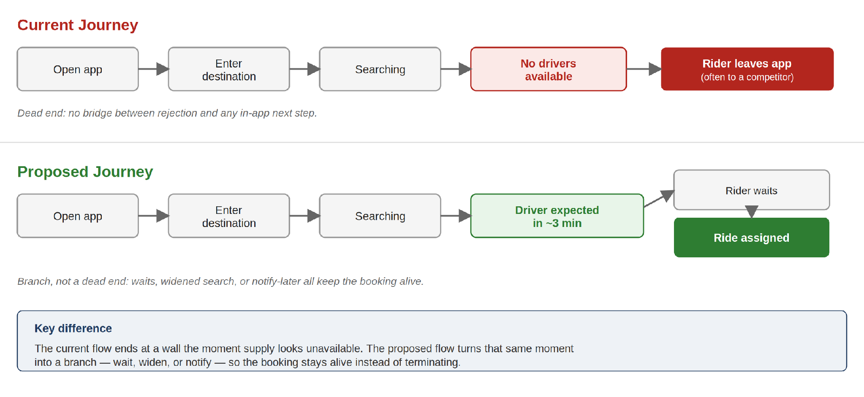
Figure 2. Current journey ends at a wall; the proposed journey branches into wait, expand, or notify.
Where the forecast isn't confident enough to promise a short wait, the journey branches instead of dead-ending, keeping the rider inside a completable flow instead of ending at a wall.

6. Root Cause Analysis
Using the “5 Whys” to get past the surface symptom:
- Why do riders abandon? → They see “no drivers available.”
- Why does that message appear? → Matching logic only considers drivers available at this exact instant.
- Why only this instant? → The product surface answers “is there a driver right now” rather than “will there be one soon.”
- Why isn't the forecast surfaced? → Ride-hailing platforms publicly describe sophisticated ETA and dispatch prediction systems. This suggests similar infrastructure could support near-term availability estimates, although rider-facing availability forecasting is not generally documented in public product experiences.
- Why wasn't it productized? → The default design pattern for availability is binary, not probabilistic.

Root cause
Availability is treated as a binary, instantaneous state in the product experience, even though the marketplace — and the models the platform already runs — treat it as continuous and predictable.
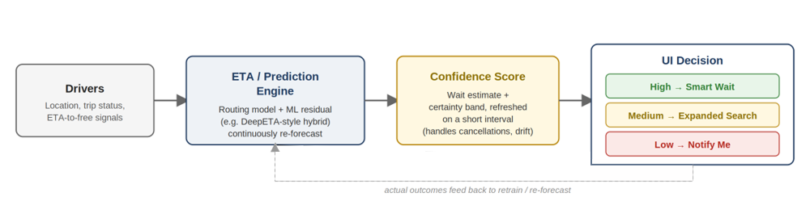
Figure 3. How an availability signal is produced today, from raw driver state to a rider-facing UI decision.

7. User Personas
Persona | Context | What “no drivers” costs them | What they'd value
Busy commuter | Books rides during weekday peak hours, often between meetings. | A rejected booking eats directly into a tight schedule; they have no slack to retry manually. | An honest, short wait estimate they can plan around — or a confident “no” so they can switch to transit immediately.
Late-night traveller | Books rides late at night, often alone, in lower-density areas. | Safety and comfort concerns are amplified by uncertainty; standing outside for an unknown duration is the worst version of this problem. | Reassurance — a concrete number, even a longer one, beats silence.
Airport traveller | Time-critical, often with luggage, frequently pre-booking. | A missed match can mean a missed flight; the stakes of a bad availability signal are highest here. | Very high trust bar — would rather see “no reliable driver, book 20 min earlier” than a broken promise.
Daily office commuter | Books the same route at similar times most weekdays; price-sensitive. | Repeated exposure to the same failure mode erodes trust fastest — this persona sees the problem most often. | Willing to trade a short wait for a lower fare (this segment overlaps heavily with existing Wait & Save adopters).

8. Problem Prioritization
Using a simple Impact vs. Effort lens across the candidate interventions surfaced by the research:

Intervention | Impact | Effort | Notes
Show predictive wait time (“Smart Wait”) | High | Medium | Reuses existing ETA/dispatch models; primary bet.
Silent search-radius expansion | Medium | Low | Mostly a backend logic change; low rider-facing risk.
Notify-me-later flow | Medium–High | Medium | Recovers demand that would otherwise be lost entirely, but needs a reliable re-notification trigger.
Guaranteed-match premium tier | Low–Medium | High | Interesting future direction; deprioritized for MVP due to driver-side complexity.
Real-time driver heatmap for riders | Low | Medium | Novelty without a clear action the rider can take; deprioritized.
Smart Wait, Expanded Search, and Notify Me are chosen because together they cover the full space of prediction confidence — high confidence (tell them), medium confidence (quietly improve the odds), low confidence (let them leave without losing the booking) — while staying within a scope buildable on existing prediction infrastructure.

9. Hypotheses
- H1: Riders abandon bookings primarily because availability is communicated as binary, not because a driver is truly unreachable in most cases.
- H2: Showing a confident, near-term wait estimate increases the rate at which riders choose to wait rather than leave the app.
- H3: A visible, algorithmically honest availability prediction improves booking completion without materially increasing driver-side cancellations or dissatisfaction.
- H4 (secondary): Riders who are shown a “notify me” option instead of a dead-end rejection are more likely to return to the same app within the hour than riders shown a flat rejection.

10. Existing Constraints
This is the section most student case studies skip — and the one that most separates a naive proposal from a credible one.
- Prediction error: any forecast will sometimes be wrong. A “3 min” promise that turns into 12 minutes is worse for trust than no promise at all — the UI must communicate confidence, not false precision (e.g. a range, not a single number, when confidence is lower).
- Driver cancellations: a driver counted as “soon available” may go offline, get reassigned, or cancel before the rider's wait completes — the system needs a re-forecast loop, not a one-time estimate.
- Traffic and real-world variance: the same DeepETA-style models that make this feasible are also the reason estimates drift; the feature inherits all the volatility already present in ETA prediction generally.
- False hope / trust cost: promising availability and failing to deliver is reputationally worse than the current honest-but-blunt “no drivers available.” The MVP must be conservative — only show a wait estimate when the model's confidence clears a high bar, and default to the current behavior otherwise.
- Driver experience: expanding search radius or nudging “soon available” drivers toward a booking must not degrade driver earnings or create a sense of being pressured into rides they'd otherwise decline.

11. Solution: Predictive Driver Availability
Three coordinated responses, applied based on the model's confidence in a near-term match:
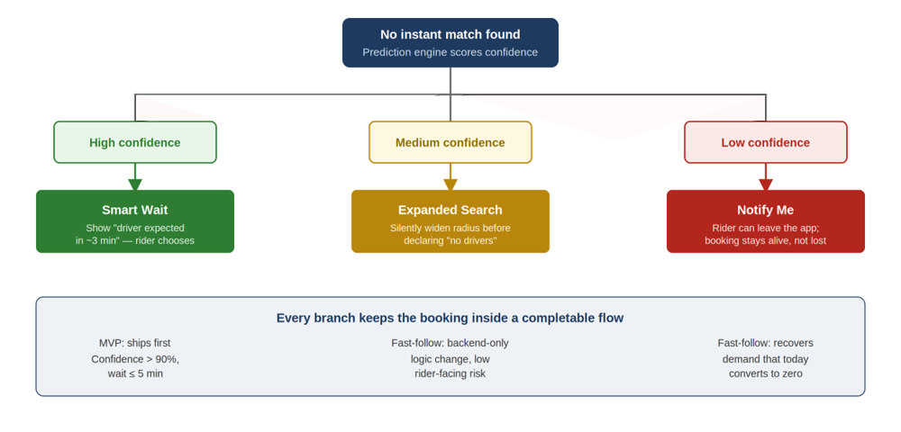
Figure 4. Solution decision tree — confidence level determines which of the three responses fires.

11.1 Smart Wait
When the prediction model is confident a driver will be available soon (e.g. a driver two minutes from finishing a nearby trip), show: “Driver expected in ~3 min” with the option to wait. This converts a dead-end into an active choice.

11.2 Expanded Search
When local supply is thin but not zero, the system silently widens the search radius before declaring unavailability — trading a slightly longer pickup distance for a completed ride instead of an abandoned one. This step is invisible to the rider; it simply changes what triggers a hard “no.”

11.3 Notify Me
When no near-term prediction clears the confidence bar, instead of a dead end, offer: “We'll notify you when a driver becomes available.” This lets the rider leave the app without the booking being lost — recovering demand from the segment of rejections that today convert to zero.

11.4 UI Wireframes (Low-Fidelity)
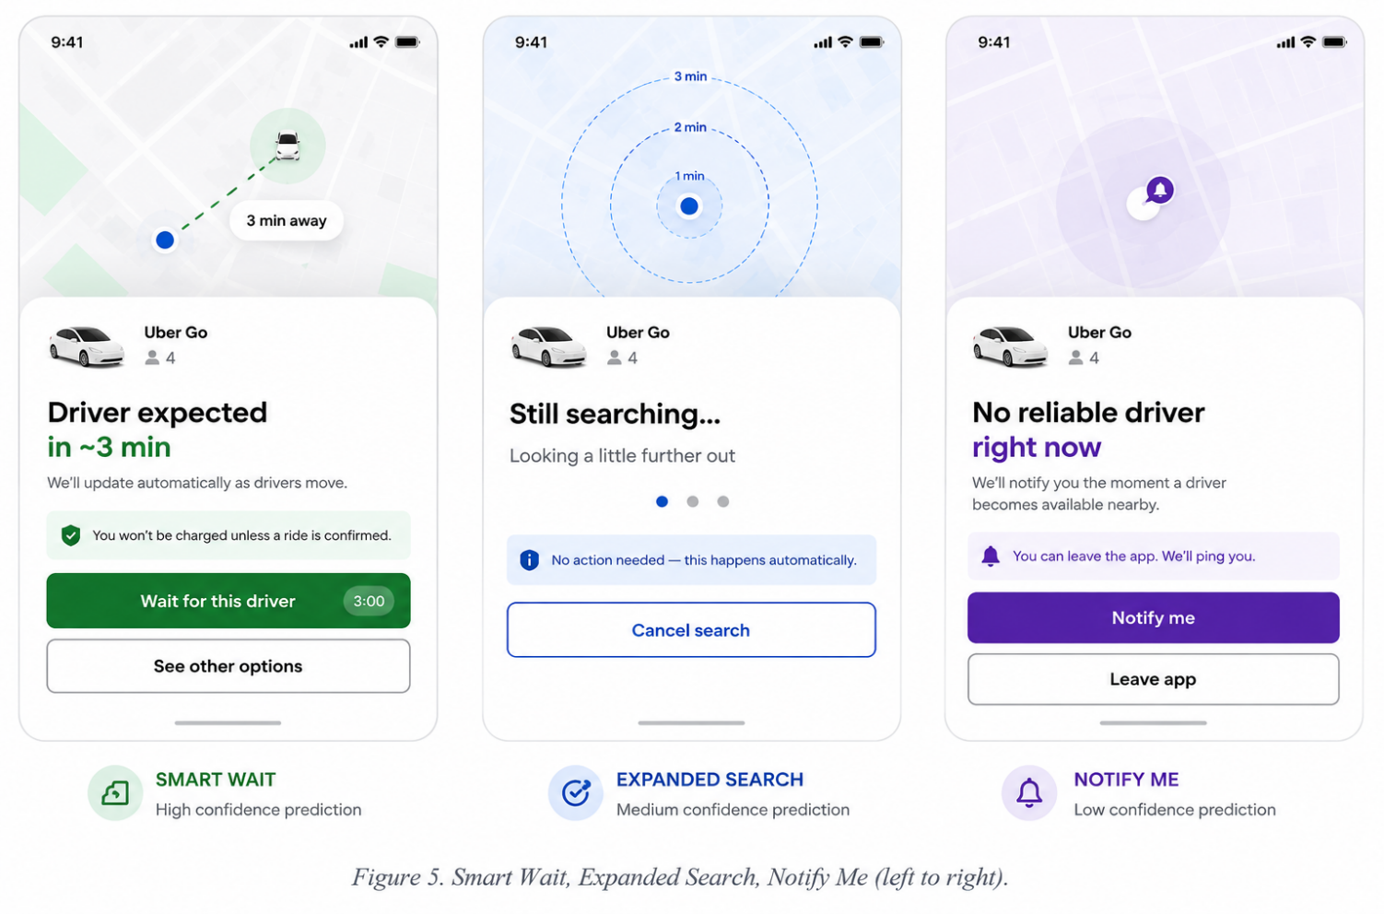
Figure 5. Grayscale wireframes — Smart Wait, Expanded Search, Notify Me (left to right).

11.5 Driver Perspective
A rider-facing feature is only sustainable if it doesn't quietly worsen the driver side of the marketplace.
- Driver experience: Smart Wait and Expanded Search don't change how a driver is matched or paid — they change what the rider sees while the same matching logic runs. Drivers should notice no difference in trip flow.
- Potential downside: if the confidence threshold is set too loosely, drivers assigned via a “soon available” prediction could be nudged toward trips they'd otherwise have more time to decline, or riders may show impatience if the wait runs long.
- Why this shouldnstar't hurt drivers: the MVP's high confidence bar (Section 14) is deliberately conservative — it only shows a wait promise when the driver is already very likely to take the trip, so it should not increase driver-side cancellation pressure.
- Trade-off: Expanded Search may increase a driver's pickup distance slightly in low-supply zones; this is monitored as a guardrail metric (driver dissatisfaction rate, Section 15) rather than assumed to be neutral.

12. Why This Solution
The case for this approach rests on the underlying mechanism, not the interface:
- Lower abandonment: converting a dead-end into a choice (wait, widen, or be notified) keeps riders inside a completable flow instead of pushing them to a competitor.
- Higher trust: an honest, confidence-calibrated estimate is more credible over time than an opaque binary rejection — and the existing complaints about Wait & Save's ETA trustworthiness show riders are already scrutinizing this exact promise.
- Uses existing supply: this is a demand-recovery play, not a supply-growth play — it makes better use of drivers who are already in the marketplace within minutes, rather than requiring new driver acquisition spend.
- No new marketplace mechanics: unlike incentive programs or new pricing tiers, this doesn't change how drivers are paid or matched — it changes what riders are told about a process that already exists.

13. MVP Scope
Illustrative MVP scope (not a final recommendation)
Bangalore only • Uber Go tier only • peak hours (8–11am, 6–9pm) • shown only when model confidence > 90% • predicted wait ≤ 5 minutes. Everything else about the booking flow stays unchanged.
This scope is an example of how tightly an MVP could be bounded — a single city, a single vehicle tier, a narrow time window, and a high confidence bar — to de-risk the launch. The exact city, tier, and thresholds should be set by whichever team owns the launch market; the principle that matters is starting narrow and conservative, not the specific numbers above.
Expanded Search and Notify Me are deliberately excluded from this first scope and sequenced in as fast-follows (Section 17: Rollout) once Smart Wait's prediction accuracy is validated in production. Shipping the riskiest, highest-signal piece first is the fastest way to learn whether the core hypothesis holds before investing in the other two branches.

14. Success Metrics

North Star
- Ride completion rate (bookings that end in a completed trip)

Business Metrics
- Booking conversion rate (search → confirmed booking)
- Incremental GMV recovered from previously-abandoned searches

User Metrics
- Wait acceptance rate (% of riders shown a wait estimate who choose to wait)
- Customer abandonment rate on the search screen
- CSAT / post-ride rating specifically for rides sourced via Smart Wait

Marketplace Metrics
- Driver utilization (are “soon available” drivers actually converting into matched trips)
- Cancellation-after-waiting rate (riders who accepted the wait but cancelled before pickup)

Guardrail Metrics
- Prediction accuracy (mean absolute error between promised and actual wait)
- Rate of “false promises” (predicted match that failed to materialize within a reasonable window)
- Driver-side dissatisfaction or complaint rate tied to Smart Wait-sourced matches

15. Experiment Design
A standard randomized A/B test at the city level to avoid marketplace network effects contaminating the comparison:
Arm | Experience
Control | Existing binary message: “No drivers available.”
Variant | “Driver expected in ~3 min — wait?” shown when the model clears the confidence threshold.
Primary metrics tracked: booking conversion, abandonment rate, and cancellation-after-waiting. Secondary: rider NPS collected post-trip, segmented by whether the trip was Smart Wait-sourced.

16. Risks
Risk | Mitigation
Prediction is wrong — the promised driver doesn't materialize, and the rider waited longer than if told “no” immediately. | High confidence threshold (>90%) gates when a promise is shown at all; fall back to today's behavior below the bar.
Rider waits too long anyway, past the point where switching would have been the better outcome. | Show a range, not a false-precision single number, when confidence is on the lower end of the accepted band; continuously re-forecast during the wait.
Driver cancels the trip they were predicted to fulfill, invalidating the promise mid-wait. | Re-forecast on a short refresh interval and immediately re-route the rider to Expanded Search or Notify Me if the original match drops.
Demand spikes (event end, weather) invalidate a prediction that was accurate seconds earlier. | Monitor for regime-change signals (sudden demand/supply shifts) and temporarily raise the confidence bar or disable Smart Wait in affected zones.

17. Rollout Plan
Stage | Scope | Goal
Stage 1 | Single city (e.g. Bangalore), peak hours only | Validate prediction accuracy and wait-acceptance behavior in a controlled, high-volume environment before wider exposure.
Stage 2 | Tier-1 cities, all hours | Confirm the effect holds outside peak-only conditions and across different supply densities.
Stage 3 | Nationwide / all markets | Full rollout once prediction accuracy and guardrail metrics are stable across Stage 1 and 2.

18. Business Impact (Illustrative Estimate)
All figures below are illustrative assumptions for a single mid-size city, used to show the shape of the opportunity — not verified company data or a committed forecast.
Step | Illustrative assumption | Result
Searches per day (one city) | 200,000 | 200,000
% of searches reaching “No Drivers Available” | 8% | 16,000 searches/day
Abandonment rate on that screen | 70% | 11,200 abandoned bookings/day
Expected recovery rate (Smart Wait + Expanded Search + Notify Me) | 15% | 1,680 recovered rides/day
Average fare | ₹180 | ₹302,400/day recovered GMV
At ₹302,400/day for one mid-size city, the same illustrative recovery rate scaled across a handful of comparable cities moves into meaningful daily GMV — with no new driver acquisition spend and no change to take-rate or driver payout, since the incremental rides come from better information, not more supply.

19. Future Scope
- Dynamic pricing tied to predicted availability confidence, rather than only current surge state.
- Predictive dispatch — proactively nudging soon-to-be-available drivers toward high-predicted-demand zones before a rider even searches.
- Driver-side incentives that reward drivers for becoming available in under-supplied zones the model has flagged.

20. Why Now
- Ride demand context: demand in dense urban markets concentrates around predictable peak windows (commute hours, event end times) — exactly the condition under which binary availability messaging fails most visibly.
- ETA prediction accuracy has matured: Uber's public engineering work shows a shift from tree-based models (XGBoost) to hybrid deep learning (DeepETA) specifically to improve prediction accuracy at low latency — the technical precondition for a trustworthy forecast is now in place industry-wide [4].
- Rider expectations for transparency are rising: the expansion of features like Wait & Save shows platforms already experimenting with exposing trade-offs to riders — this proposal extends that trend to availability, the one major variable still hidden entirely [2].
Why now, in one line
The prediction infrastructure this feature needs already exists and is mature; what's missing is the product decision to point it at the rider instead of only at internal routing and pricing.

21. Conclusion
Riders don't abandon bookings because drivers are truly unavailable,they abandon because the platform tells them nothing about what happens next. That single design gap, treating a continuous, predictable marketplace as a binary yes/no, is costing completed rides that the supply already exists to fulfill.
Predictive Driver Availability closes that gap by reusing prediction infrastructure these platforms already operate, and routing its output to a rider-facing decision instead of only an internal one. Smart Wait, Expanded Search, and Notify Me together convert every rejection into a branch instead of a dead end, at effectively zero incremental supply cost.
The illustrative math in Section 18 shows the shape of the opportunity even at conservative recovery rates, and the underlying technology — mature ETA prediction, rising rider expectations for transparency, and a competitive field that hasn't claimed this surface yet — makes now the right moment to build it.

22. References
- Google Play Store (Uber Rider app reviews); Uber Support Community and Reviews.io; ConsumerAffairs.com and BBB.org complaint archives.
- Uber Newsroom — “Uber's new features to make rides more affordable, accessible and elevated” (2025), covering Wait & Save and Price Lock rollout in India.
- Uber, Lyft, Ola, Rapido, Grab, Bolt — public product surfaces and rider-facing help documentation.
- Uber Engineering Blog — “DeepETA: How Uber Predicts Arrival Times Using Deep Learning”; “What's My ETA? The Billion Dollar Question”; “Engineering More Reliable Transportation with Machine Learning and AI at Uber”; third-party technical analyses of Uber's Michelangelo ML platform.
This case study was built from publicly available reviews, engineering blogs, and product documentation as of mid-2026. It does not use any confidential or internal company data. Business-impact figures are illustrative estimates for this exercise, not verified company forecasts.
Appendix A: Research Methodology
This case study draws on four categories of research, each answering a different question:
Category | Sources used | Question it answers
User research | Play Store reviews, Uber/Lyft support communities, ConsumerAffairs, BBB, social commentary on Wait & Save [1] | Do riders actually experience and complain about this?
Technical research | Uber Engineering blog: DeepETA, “What's My ETA?”; third-party analyses of Michelangelo ML platform [4] | Is forecasting near-term availability technically feasible with tools these platforms already operate?
Product/competitor research | Uber, Lyft, Ola, Rapido, Grab, Bolt product surfaces and help documentation [3] | Has anyone already solved this, partially or fully?
Market research | Uber Newsroom feature announcements, 2025 [2] | Is there already validated user demand for wait-based trade-offs?

What the Technical Research Shows
Uber's engineering blog describes ETA prediction as a hybrid system: a physical routing engine estimates a baseline travel time, and an ML model (DeepETA) predicts the residual against real-world outcomes, continuously retrained via the Michelangelo platform [4]. Two implications for feasibility: the infrastructure for real-time, low-latency prediction at marketplace scale already exists and is proven, and these systems are designed to update frequently — which matters for keeping a “~3 min” promise honest rather than stale.

